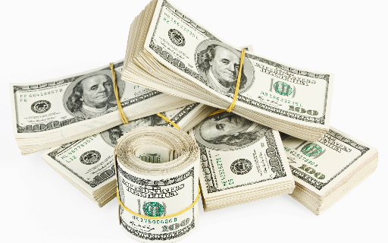

Blue Gem’s - Bulk Vending Affiliate Program - Profit Schema
Gum Balls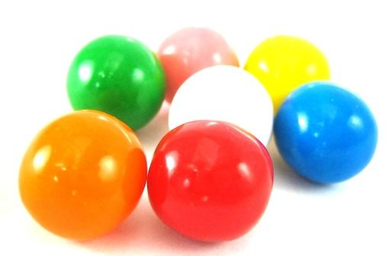  Price Per Vend  R2.00  Profit and ROI per Vend  Profit per Vend  R1.08  ROI per Vend  1.74 (1.08/0.62 = Profit/Investment)  Cost Per Vend  Total Cost  R0.92  Just affiliate host’s commission  R0.30 (R2.00 (price) * 15%)  Just stock  - Cost: R0.62 (as a 850 package is R527.00) | Sherbert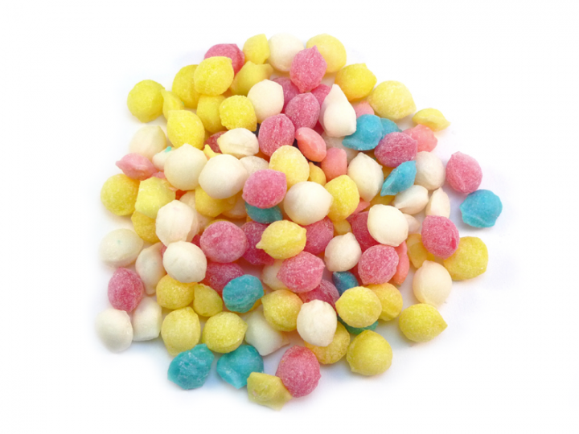  Price Per Vend  R5.00  Profit and ROI per Vend  Profit per Vend  R2.05  ROI per Vend  0.932 (2.05/2.20 = Profit/Investment)  Cost Per Vend  Total Cost  R2.95  Just affiliate host’s commission  R0.75 (R5.00 (price) * 15%)  Just stock  - Cost: R2.20 (see breakdown below*)

* Sherbert Cost Per Vend Breakdown
- We can configure the state of the dispensing wheel to 6 different states. Each yields a different gram amount per vend.
- Cost per gram: R0.11 (as a 1kg package is R114.00).
- Grams dispense: 20 grams per vend.
The below table shows yields for the different dispensing wheel states
Dispensing wheel states | Yields per vend (grams)
1 | 9.5
2 | 12.5
3 | 18
4 | 20
5 | 22.5
6 | 23.5
The below image shows a dispensing wheel with grooves used for configuring the states. Unlike our one, that has 6 grooves, this one has 8.

